23CSE202 DATABASE MANAGEMENT SYSTEMS
S3 B.Tech CSE
Department of Computer Science and Engineering
Amrita School of Computing, Amritapuri Campus

2. UI Design Document

Group No : B7
Team Members :
Roll No | Student Name
AM.SC.U4CSE25115 | Dhanya Krishna
AM.SC.U4CSE25114 | Devika B
AM.SC.U4CSE25130 | Lakshmi V S

Project Title : FoodExpress- An Online Food Delivery and Restaurant Management System

2.1. Functional requirements:
[list the main functionalities required]
1. User and Restaurant Management
2. Order Processing
3.Delivery and Feedback

.

2.2. Non functional requirements:
[list the main qualitative features required]
1. Performance
2. Reliability & Data Integrity
3. Usability & Scalability

2.3. List of AI tools used for building UI(if any):
1.ChatGPT
2. Claude
3.Gemini
4.Grok

2.4. Prompt (if any) :
Sl. No | Name of the tool | prompts
1 | Grok | Design a modern responsive UI for an online food delivery system called FoodExpress. Include customer login, restaurant listing, food menu, shopping cart, checkout, order tracking, restaurant dashboard, and delivery partner dashboard using HTML, CSS, Bootstrap, and JavaScript with a clean orange-and-white theme.
2
3

2.5. List of files:
FoodExpress/
├── README.md
├── cart.html
├── checkout.html
├── delivery_dashboard.html
├── delivery_login.html
├── home.html
├── index.html
├── login.html
├── menu.html
├── order_tracking.html
├── profile.html
├── register.html
├── restaurant_dashboard.html
├── restaurant_login.html
├── restaurants.html
├── css/
│ ├── responsive.css
│ └── style.css
├── images/
│ └── logo.svg
└── js/
├── cart.js
├── data.js
└── script.js

2.6. UI Screenshot:
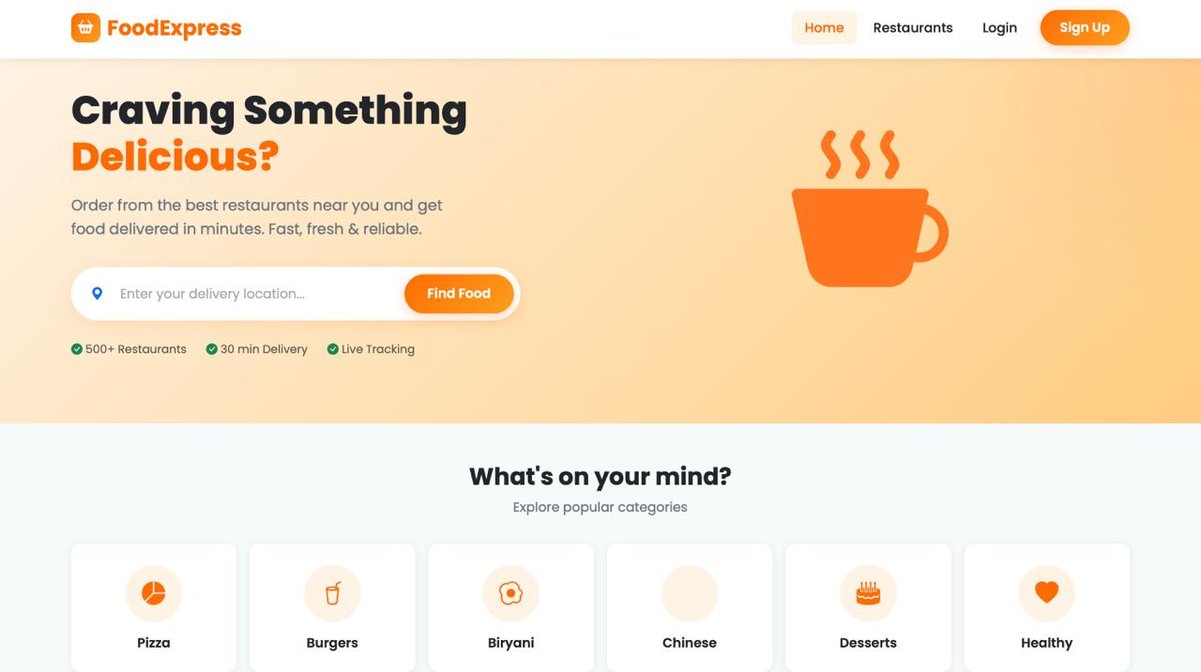

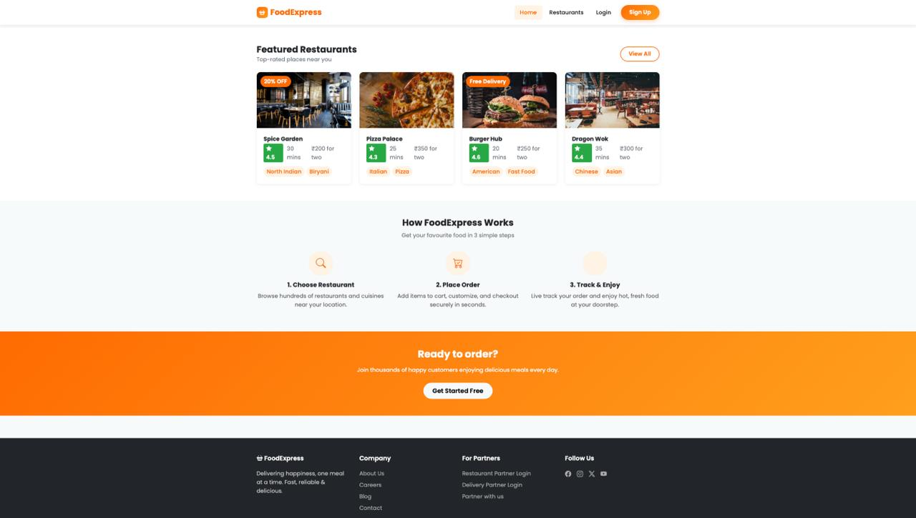

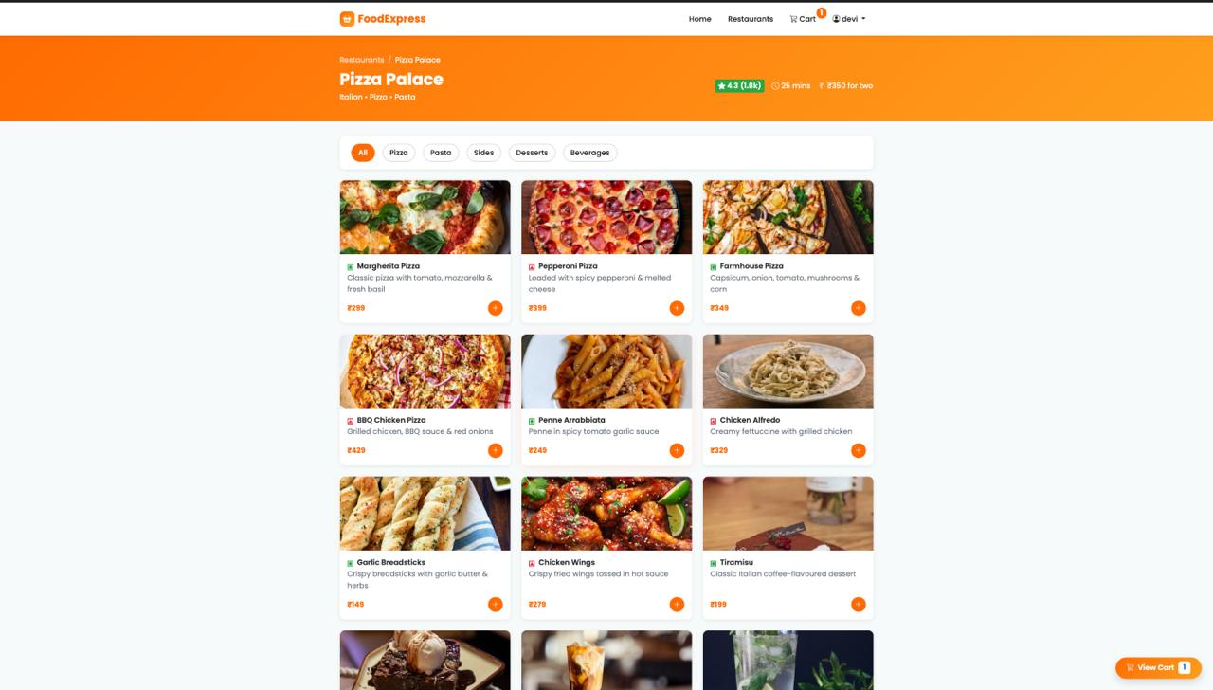
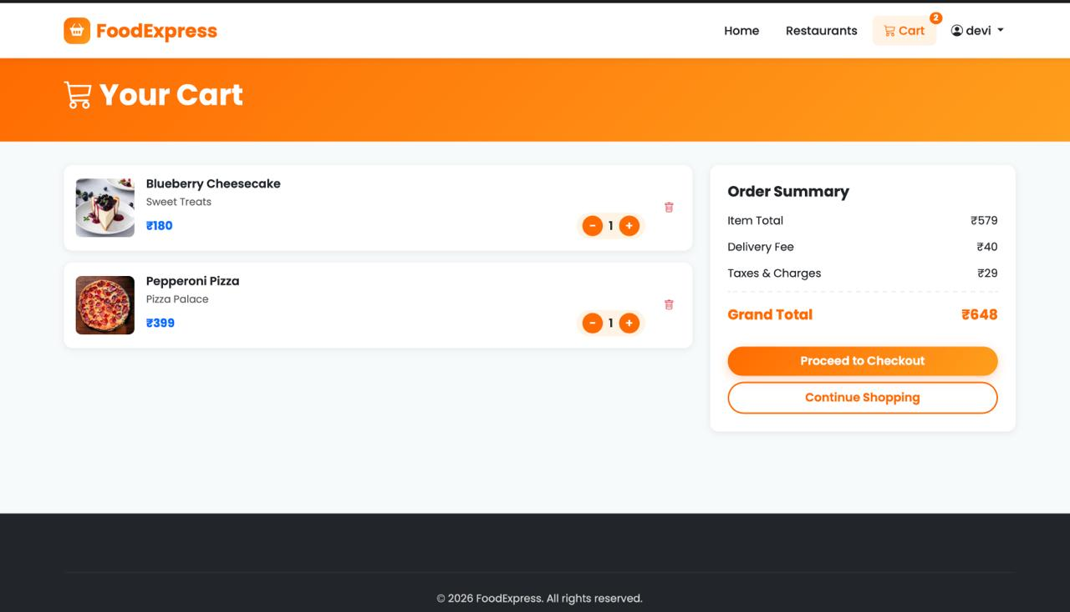

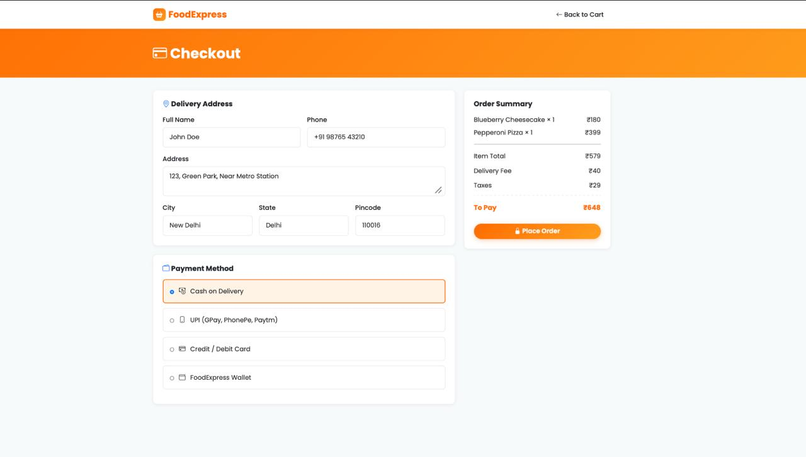
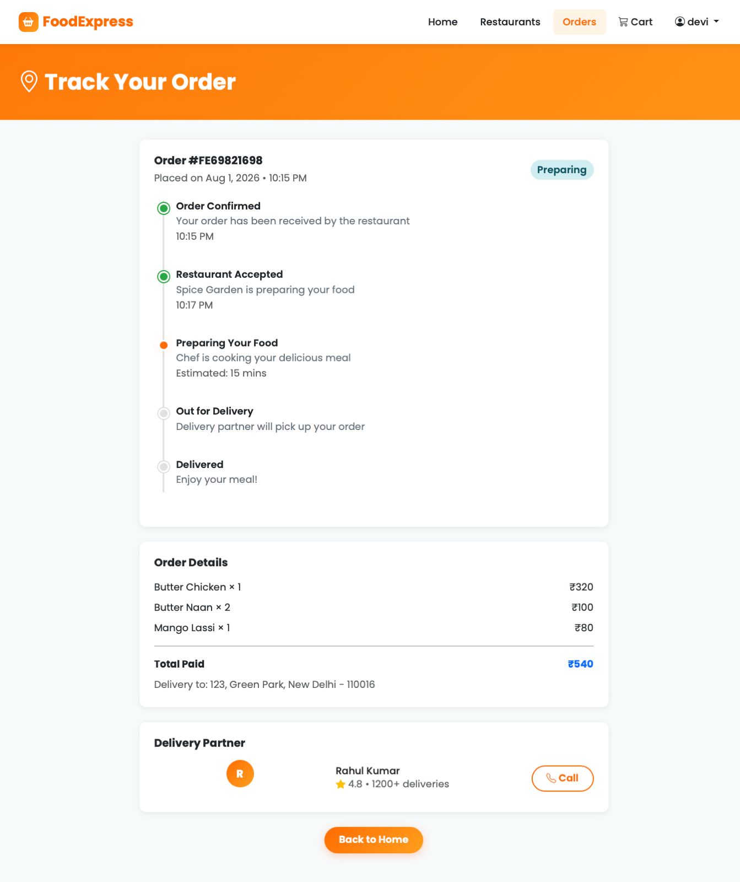
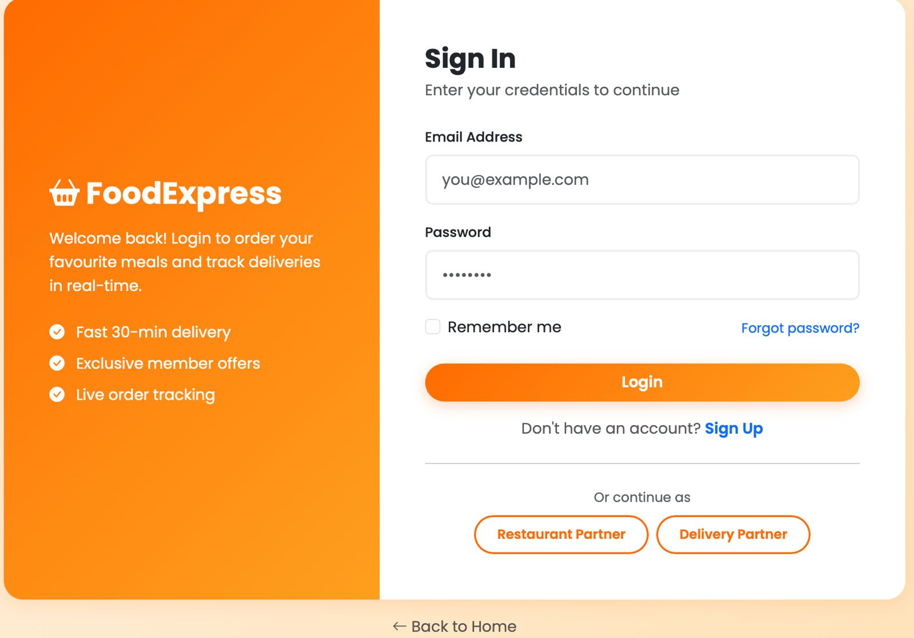

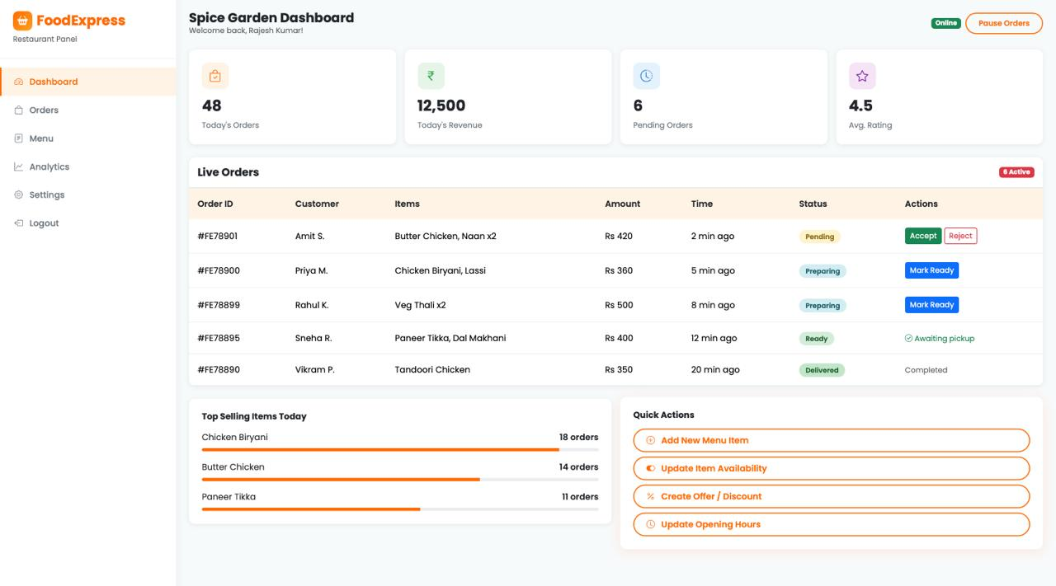
2.7. GitHub Link:
https://github.com/Dhanya-Krishna/DBMS-Project.git

